

NZSA TOP OF THE SOUTH BRANCH
NEWSLETTER
1 April 2021

Send news to the Branch Editor at cj.ward@xtra.co.nz or phone 03-5469818. Let us know about meetings, coming events, book launches, new publications, literary successes, etc. Tell us if you change your email address. Past news-letters are archived for two months on our website www.topwriters.co.nz
Follow us on Facebook at https://www.facebook.com/topwritersNZSA/
and join our Facebook group www.facebook.com/groups/TOSWriters

WRITERS AT LUNCHTIME

Writers at Lunchtime takes place 11.30 am – 1.30 pm on the first Wednesday of every month (except January) at the Café at Founders Park in Nelson. There is usually a guest speaker at 12.30 pm.


The next meeting will be on Wednesday 7 April. The guest speaker will be freelance journalist Tracy Neal, who will be talking about her work writing for magazines, newspaper and radio. Tracy is a local writer who until recently was a senior reporter for Radio New Zealand (RNZ). She has extensive experience contributing to magazines and newspapers, including Nelson Mail. To see some of her most recent articles for RNZ, go to https://www.rnz.co.nz/authors/tracy-neal.

Founders Park is at 87 Atawhai Drive, Nelson. Enter through the Windmill; there is plenty of parking on Atawhai Drive. Everyone is welcome. Come any time from 11.30 am, but make sure to be there at 12.30 pm for Tracy’s talk. For more information Belinda at bmellor12@icloud.com or Sue at 021 061 6470.

TAKAKA BOOK LAUNCH – MARK HAMISH-SCOTT

Everyone is welcome to Takaka Library on Wednesday 7 April at 2 pm to listen to local author Mike Hamish-Scott in conversation with Mik Symmons on his book The Last 8 Possessions.

When Michael Hamish-Scott met the gypsy on a dark and foreboding Dartmoor as night was approaching, he was unprepared for what she told him about possessions. Through Europe and Africa, India and Asia, he searches for simple living people and discovers after two years of travelling she was right – but she’d said nothing about the most important possession. It was no gypsy secret, just something the gypsies had without thinking about it.

This is a free event. The Last 8 Possessions will be for sale for $30.

THE BOATHOUSE CELEBRATES NELSON WRITERS

The Boathouse Society is proud to collaborate with Page & Blackmore Booksellers and present a celebration of Nelson writers on Wednesday 7 April, 6 – 8 pm.

Two of our most loved Nelson-based writers, Karen Stade and Alexandra Tidswell, take the stage, introduced and chaired by Jacquetta Bell. They will discuss their work, and then answer questions from the audience.

Karen Stade is a noted researcher and writer of Nelson history, with more than 30 years of professional writing experience. Read more about her here:
http://www.topwriters.co.nz/karen-stade1.html

Alexandra Tidswell is a historical fiction writer whose first novel, Lewisville, based on her ancestor Martha Grimm, made the best-seller lists.

The Boathouse is at 326 Wakefield Quay, Nelson. There will be some light complimentary canapés, and the bar will be open to purchase drinks. This is a free event but bookings are required – olivia@theboathousenelson.co.nz

BOOK LAUNCH AT NELSON MUSEUM

Come and hear Professor Richie Poulton talk about directing The Dunedin Study—the world's foremost longitudinal study of social development—for over twenty years, and about the remarkable book that makes the findings of the study available to a both a general and a specialist readership. The launch takes place at Nelson Provincial Museum on Wednesday 7 April, 6 - 8 pm. Special guest: Sir Graham Henry.

The book The Origins of You: how childhood shapes later life is co-authored by Jay Belsky, Terrie E. Moffitt, Richie Poulton and Avshalom Caspi. After tracking the lives of thousands of people from birth to midlife, these four of the world's preeminent psychologists reveal what they have learned about how humans develop. In The Origins of You, the authors share what they have learned about childhood, adolescence, and adulthood, about genes and parenting, and about vulnerability, resilience, and success. Painstaking and revelatory, the discoveries in The Origins of You promise to help schools, parents, and all people foster well-being and ameliorate or prevent developmental problems.
The book The Origins of You: How childhood shapes later life will be available for sale at the event, and from Volume bookshop and website until the event, for a special price of $95 (RRP $106).

The museum's current exhibition Slice of Life highlights the significance of The Dunedin Study. The findings of the study are also explored in the television series Why Am I?

THE SPACE BETWEEN – ANTHOLOGY LAUNCH AT NMIT

The dream of having their work published becomes a reality for former Nelson Marlborough Institute of Technology (NMIT) writing and design students with the launch of The Space Between on Thursday 8 April, 5.30 pm.

The anthology contains a selection of works published in the 2017 to 2020 editions of the Nelson based literary and arts online journal, kiss me hardy. Much of the work in the anthology was produced by students on the Diploma in Writing for Creative Industries.

Cliff Fell, poet and former NMIT creative writing tutor, says kiss me hardy was a wonderful, independent way of showcasing student writing and he hopes it will continue as an online journal, especially with the closure of the creative writing programme. ‘This anthology includes writing that has been shortlisted for significant New Zealand literary prizes, and demonstrates the high standards NMIT creative writing students have consistently achieved.’

Freelance writer and editor Kerry Sunderland, who also supported the students to publish the four online editions of kiss me hardy, says she is pleased the four editors – Jenni Komarovsky, Carol Neilson, Lisa Morley-Gray and Angela Zame – took the initiative to get the project off the ground. ‘It’s testament to their passion for storytelling and demonstrates what they’ve learnt throughout their studies; practising is the best way to learn about writing and the publishing world,’ she says.

The launch of The Space Between takes place at the G Block Atrium, NMIT, Nile Street, Nelson. Please RSVP to events@nmit.ac.nz. The book will be available to purchase for $25 at the launch or by emailing kissmehardyanthology@gmail.com

TALK BY JEAN GORMAN: INTRODUCTION TO THE CRUSADES

Everyone is welcome to Richmond Library on Thursday 15 April, 5.30 pm, to hear Jean Gorman share her knowledge of The Crusades.

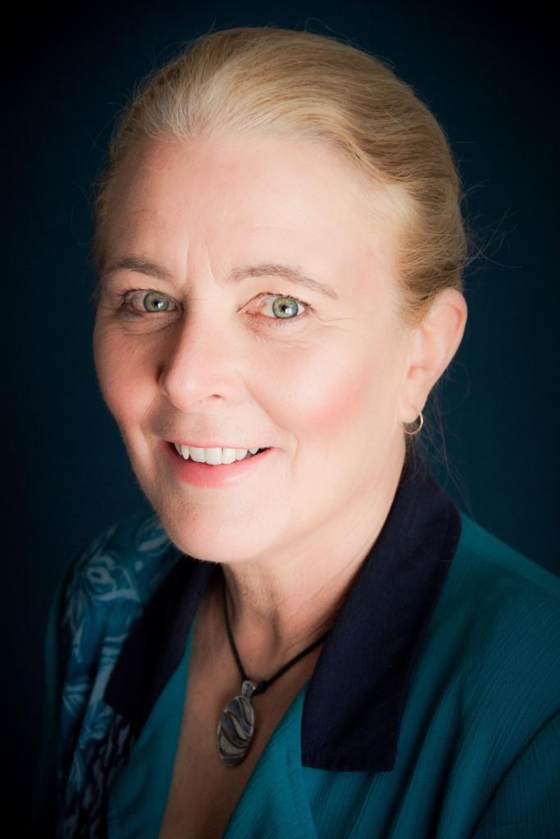
Jean Gorman, the Secretary of NZSA Top of the South branch, is the well- known author of the Lionheart Chronicles, historical novels set during the reign of King Richard the Lionheart – a time of crusades, devious international politics and warfare. Read more about Jean’s books here: http://www.topwriters.co.nz/jean-gorman.html

In this fascinating talk, Jean shares her knowledge of The Crusades. ‘Was it an age of knights and chivalry? An age when self-serving, powerful and socio-pathic men had free rein? Was this different from today? Why did King Richard the Lionheart command the respect and devotion of his men, whereas his brother, King John, became the butt of stories like Robin Hood? Can we believe what we are told of these men? Probably not – deeds define the man,’ says Jean.

If you are interested in history then this talk is for you. It’s a free event.

MAWHERA WRITERS (GREYMOUTH)
Formerly West Coast Writers, this group welcomes writers of all genres to write together, get feedback on their work, and to discuss all things ‘writing’ in a respectful, encouraging environment. Don't worry about your level of experience – everyone is welcome! The group meets on the first Sunday of each month, 11 am – 1 pm, at CoRe (New Coaster’s Office), 38 Albert Street, Greymouth. Gold coin donation for venue appreciated. Their next meeting will be on Sunday 4 April. Contact Katrina Brown at kbtaiwan@gmail.com for more details and to go on the group mailing list. Follow them on Facebook at https://www.facebook.com/groups/mawherawriters/
to find and share writing-related updates and discussion relevant to the group.

STEMWRITERS GROUP AT NELSON LIBRARY

STEMWriters is a small group with widely varying interests in writing, from short fiction to social commentary, social history and poetry. They meet on the second and fourth Tuesday of each month at 1 pm at the Elma Turner Library in Nelson. The next meetings will be on 13 & 27 April. For more information contact Jackie Cook at taongajac@gmail.com

NELSON ROMANCE WRITERS

The Nelson branch of Romance Writers of NZ (RWNZ) usually meet on the second Saturday of every month. They meet at 2 pm at the National Party Office, corner of Waimea & Quarantine Roads, Nelson. Visitors are always welcome. If you are not an RWNZ member, you are welcome to attend a meeting before deciding whether or not to join.

The next meeting will be on Saturday 10 April, when the topic will be writing dialogue in fiction. For more information contact Annika Ohlson-Smith at 03-548 5561, email amos46@xtra.co.nz

WRITERS OF PICTON

Writers of Picton usually meet on the first Monday of the month (except January) at 1.30 pm in the upstairs meeting room at Picton Library, but meeting times and venues can vary.

As the scheduled date for the next meeting would be Easter Monday, it has been changed to Monday 12 April. The writing exercise is 200-400 words on the topic of ‘Climate change expectations’. For more information contact Irene Thomas at 03-573 5501 or 027 249 3146, or email pandi.goodhope@gmail.com
GOLDEN BAY LIVE POETS

Golden Bay Live Poets meet monthly at The Mussel Inn, Onekaka. Their next meeting is on Thursday 15 April at 7.30 pm when the guest poet will be Slam poets champion Jessie Fenton.

Jessie’s poetry is enthusiastic, thoughtful, and uses humour to explore difficult subject matter. She is a national slam finalist, Poetry Idol winner, and Word: the Front Line coach. Jessie has been published in Starling and Otago University's Manifesto: an anthology of political poetry.

Everyone is welcome to attend or participate. Bring a poem, a song or a story. Koha entry. For further information please contact Mark Raffills at mark@drycrust.com or visit the group’s Facebook page: https://www.facebook.com/nelsonmotuekagoldenbaylivepoetssociety

CREATIVE WRITING CLASS IN NELSON

Have a story to tell? Come to Gillian Entwistle’s creative writing class and enjoy being part of a fun and supportive writing group.

The class began three years ago as a short programme at Nelson Marlborough Institute of Technology (NMIT). This year it has moved to the function room of The Prince Albert, 113 Nile Street, Nelson. In the class, over 10 weeks a particular literary theme is developed; past examples include: character development, setting, and of course last year reflections on lockdown. The class has a say in what the next term’s focus will be and, as a tutor, Gill facilitates and guides the class with their writing through activities and relevant resources.

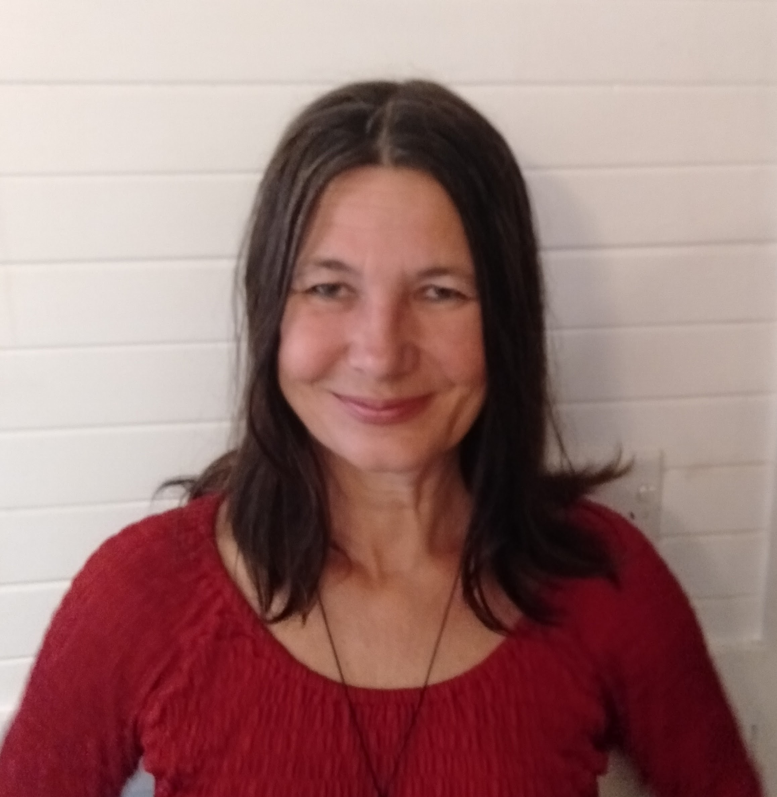
Gill studied an MA in Creative Writing in the UK and since moving to New Zealand has published short fiction in local magazines such as Wild Tomato. She taught academic writing at NMIT and now is teaching creative writing classes at Waimea College and Victory Community Centre, as well as this course at The Prince Albert.

Most importantly, the class is fun, and with no formal assessments, the goal of each occurrence is to publish a class portfolio, showcasing the enormous talent that each learner has. The classes run from 5.30 to 7.30 pm every Wednesday, starting on Wednesday 5 May. The cost is $80 for 10 weeks, but Gill is happy to allow potential students to give it a go before enrolling, to dip their toe in the water. To find out more, contact Gill on 022 089 5994 or blu.top@outlook.com

2021 PAGE & BLACKMORE SHORT STORY COMPETITION
in association with NZSA TOP OF THE SOUTH BRANCH

The 2021 Page & Blackmore Short Story Competition is open for entries. This national short story competition is jointly sponsored by Nelson’s Page & Blackmore Booksellers and NZSA Top of the South Branch, with prizes awarded half as book vouchers and half as cash.

The word limit is 1500 words. Writers may submit as many entries to the competition as they like, provided an entry fee of $20 is paid for each story. All stories receive feedback, with the judge providing a written assessment of the ten short-listed stories. The top three entries receive prizes to the following value: First, $500; Second, $300; Third, $200. Submissions must be made by email to tosshortstorycomp2021@gmail.com

The competition will be judged by Rajorshi Chakraborti, an Indian-born novelist, essayist and short story writer who now lives with his family in Wellington.
The closing date for entries is Friday 30 April. The results of the competition will be announced on Friday 4 June.

The full conditions of entry and an entry form for the 2021 Short Story Competition can be downloaded from http://www.topwriters.co.nz/page--blackmore-competition.html Please share this information with anyone who may be interested. If you have any queries, contact Lucy at tosnzsa15@gmail.com.

BLACKBALL READERS AND WRITERS FESTIVAL 2021

The second Blackball Readers and Writers Festival takes place over Queen’s Birthday Weekend, from midday Saturday 5 June through to the evening of Sunday 6 June, once again in the beautiful setting of the local school. This intimate festival is a contribution to the West Coast transition economy. The theme is activists, renegades and recluses.

To begin the festival, biographer Pat White and editor and environmental writer David Young will ‘recover’ the work of Greymouth-born Peter Hooper, poet, teacher, novelist, environmentalist and mentor to young writers. After a break, Catherine Woollet will interview Sandra Arnold, whose work includes a book on parental bereavement, a short fiction collection and her third, recent historical novel, The Ash, the Well and the Bluebell.

On Sunday morning, Paddy Richardson will talk with Becky Manawatu, whose first novel Auē has won major prizes, and Elspeth Sandys will speak with Jeffrey Paparoa Holman about her extensive writing life with a focus on her latest work, A Communist in the Family: Searching for Rewi Alley.

In the afternoon, Paul Maunder will talk with Nicky Hager, NZ’s best known investigative journalist, whose books have uncovered environmental, political and military skulduggery, and Caroline Selwood will discuss with Tim Jones and Kathleen Gallagher their source material and their motivation, leading to a more general discussion on this theme.

Other items in the programme are a book launch, a poetry reading, an evening of storytelling and a wrap-up dinner at the Hilton with a sharing of letters, either real or fictional, chaired by Stevan Eldred-Grigg.

There is a range of accommodation available and car sharing can be facilitated. The Festival has a limit of 50 guests, so register early with wkcultur@gmail.com
Cost: Full Festival: $80, including lunches and Saturday dinner.
One day: $40. Session: $20.
The Festival is supported by Creative Communities and Cycle Journeys.

