NZSA TOP OF THE SOUTH NEWS
26 May 2017
Send news to Chrissie at cj.ward@xtra.co.nz or phone 03-546-9818. Let me know about meetings, coming events, book launches, new publications, literary successes, etc. Tell me if you change your email address. Past newsletters are archived for a month on our website www.topwriters.co.nz. Follow us on Facebook at https://www.facebook.com/topwritersNZSA/
BOOK LAUNCH IN NELSON

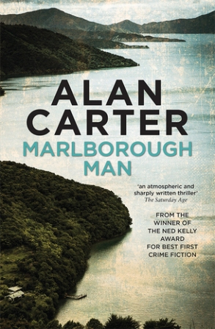
Alan Carter’s latest crime novel, Marlborough Man, will be launched on Wednesday 31 May, 6-7 pm at Volume Bookshop, 15 Church Street, Nelson. Drinks and nibbles provided.

Nick Chester is working as a sergeant for the Havelock police. If the river isn’t flooded and the land hasn’t slipped, the Marlborough Sounds are paradise – unless you are also hiding from a ruthless man with a grudge, in which case, remote beauty has its own kind of danger. In the last couple of weeks, two local boys have vanished ...
Alan Carter is an outstanding crime and thriller writer, who now lives at Canvastown, near Havelock. Read more about him here: http://www.topwriters.co.nz/alan-carter.html
Come and meet Alan, hear him read and take home a signed copy of his book!
Pre-order a copy here: https://volume.circlesoft.net/p/novel-marlborough-man?barcode=9781925164534

MURDER IN THE LIBRARY

The Ngaio Marsh Awards, in association with the New Zealand Book Council and Nelson Libraries, invites Top of the South booklovers to a thrilling free event featuring three talented New Zealand crime writers – two of them local.
As crime writing has evolved from puzzle-like mysteries to novels delving deeply into people and places, it has continued to be the world’s most popular form of storytelling. But just what makes the genre so fascinating?
Come along to the Elma Turner Library in Nelson on Thursday 1 June at 6 pm for a 6.15 pm panel discussion led by local author and historian Karen Stade. Auckland writer Fiona Sussman and Ruby Bay author David Briggs, whose latest novels are in the running for the 2017 Ngaio Marsh Awards, will be joined by Havelock-based crime writer Alan Carter to discuss how they craft great stories and blend page-turning crime plots with fascinating characters and real-life themes.
David Briggs is a published poet who immigrated from the UK in 2009. He lives in Ruby Bay with his wife and three dogs. His novel The Direction of Our Fear centres on the lives of four everyday people in Wellington while a potential terrorist threat looms.
Alan Carter won a Ned Kelly Award for his debut crime novel Prime Cut, starring an Asian-Australian detective in Perth. His newest novel, Marlborough Man, is a mystery set in the Top of the South, where he now lives.
Fiona Sussman's The Last Time We Spoke delves into the aftermath of a brutal home invasion, and ‘shows the freshness and daring of Alan Duff's Once Were Warriors’ (Takahe magazine) while being ‘a gripping story of grief and redemption’ (Sunday Mirror).

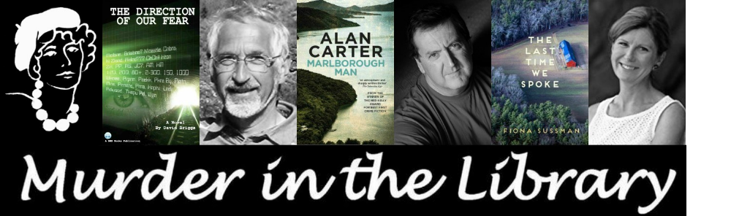

WRITERS AT LUNCHTIME

The next Writers at Lunchtime meeting is on Wednesday 7June, 11.30 am – 1.30 pm. The guest speaker at 12.30 pm is Justin Eade, who will talking about how he became a full-time writer and his adventures in the film and theatre worlds.

Justin Eade is a screenwriter and playwright from Nelson who has written 19 film scripts and seven plays. In 2011 he won the Kairos Prize screenwriting competition in Los Angeles with a script ‘Blue Water Metal’ which was optioned last year by a US producer. He has written sketch comedy and sitcom episodes for TV3 and had many radio plays and short stories produced for RNZ National. Locally he has recently staged the plays ‘Central Otago Man’ and ‘Maungatapu’, and most recently ‘An Avro to Naumai’, which was part of Nelson Heritage Week 2017.

Writers at Lunchtime takes place at The Prince Albert, 113 Nile Street, Nelson (car parking is accessed from Tasman Street). Come any time from 11.30 am, but make sure you are there at 12.30 pm for Justin’s talk. Everyone is welcome. Gold coin donation appreciated. For more information contact Chrissie on 03-546 9818.

THE WRITER’S TOOLKIT – WRITING WORKSHOPS IN NELSON

Michelanne Forster will be running a course of five writing workshops every Thursday at 9 – 11.30 am from 8 June to 6 July. The venue is Volume Bookshop, 15 Church Street, Nelson. The cost is $250. It is limited to six participants, and bookings are essential. To book, contact books@volume.nz

Fiction’s purpose is to create a continuous and engaging dream in the mind of a reader. This course looks closely at the key craft skills writers use, unpacking complex ideas in a creative and practical way. Topics include finding and honing your own voice as a writer, understanding and successfully using point of view, experimenting with innovative genre-crossing, types of narrative structure, creating character and generating plot from character journey, and ways to self-edit and redraft work. Each session offers pertinent quotes from established writers, examples from works of fiction, practical class exercises, group work, feedback and optional home tasks.

Michelanne Forster has published books for children, short stories and plays. Her work has been performed on television and radio, and by theatre companies throughout New Zealand and overseas. She taught creative writing classes for Auckland University’s Continuing Education Programme from 2008 to 2016.

MAPUA COMMUNITY LIBRARY LITERARY FESTIVAL

The 2017 Mapua Community Library Literary Festival takes place between
15 – 17 September. This will be the fourth Literary Festival the Library has held, and they anticipate it will be as popular as in previous years.

The theme this year is ‘Journeys’ – journeys real and imagined, journeys in time and space, journeys of the mind and the heart.

The Festival begins on Friday afternoon with a story telling and drama event for local schools, followed by a literary’ quiz in the evening. On Saturday there are conversations with authors and a story telling session for children, and the day concludes with a poetry evening. The festival finishes on Sunday with more conversations with authors. Ten well known New Zealand authors have accepted invitations to speak at the Festival, including: Fleur Beale, Elizabeth Knox, Sarah Laing and Paddy Richardson. Most Festival events will be held in the Mapua Community Hall, 72 Aranui Rd., Mapua. A full programme and ticketing information will be available in early July 2017.

Short story competitions for children and adults will be run in conjunction with the Festival. The adult short story competition is open to anyone over the age of 15 years. It will be judged by Bridget Auchmuty. The entry fee is $10 per story. The theme is ‘Journeys’ and the word count is up to 1500 words. Prizes in the form of book vouchers from Nelson’s Volume Bookshop are: First, $100; Second $50. Entries close on 31 July. For full conditions of entry and an entry form, go to http://www.mapuacommunitylibrary.co.nz/

TOP WRITERS RADIO SHOW

The fourth programme in the Top Writers Radio Show 2017 season featured Gaelynne Pound interviewing Amy Hindley on her autobiography Not a Leg to Stand On. Podcasts of this and earlier programmes are available on the branch website here: http://www.topwriters.co.nz/radio-show.html.

The dates of future programmes in this season are:
Sat 3 & Mon 5 June: Alan Carter on his new crime novel Marlborough Man
Sat 17 & Mon 19 June: Belinda Mellor on her Silvana series of fantasy novels

Fresh FM is a Community Access radio station which can be heard on 104.8 in Nelson-Tasman, 95.0 in Takaka and 88.9 in Blenheim. It also operates in the inner Nelson City area on 107.2. To find out more about the station, see www.freshfm.net

NEW BOOKS FOR SUE PERKINS

Sue Perkins has two books released in the same week. The first is a contemporary romance which she has entered in the Amazon UK Storytellers 2017 Competition. ​All reviews by readers go toward the voting for the books in this competition. The book is available in ebook and paperback formats and can be found at http://tinyurl.com/suemiri Reviews can be left by clicking on the link for reviews.

Miri's Inheritance is the first book in the Village of Shadows Series. Miri inherits a cottage from the grandmother she's never met. Gavin, the solicitor's clerk, helps her settle in and sign all the necessary documents. The isolated village has several cottages, but none of the neighbours are friendly. One unknown person repeatedly breaks in and searches Miri's new home. Who is this mysterious person and what does he want? Will Gavin protect her now his official duties are over?

The second book is a fantasy with a hint of romance set in an alternate world.
Broken Spire is the first book in the Rak Shoma series. The book is available in paperback and ebook and can be found on Amazon at
http://tinyurl.com/rakshoma1 Reviews can also be left on the Amazon page for this book.​

Ash's silvery purple hair sets her apart from her peers. At the magic college of Spires a few senior maeven consider her magic to be alien and unsuccessfully try to expel her. Ash feels a compulsive attraction tempting her to enter the broken North Spire. She believes this off-limits ruin holds the answer to her origins, but is not willing to take the chance of expulsion from Spires.
Orm, Ash's equally talented classmate, is determined to support the girl he considers his soulmate, and promises to help her find out the secrets of the North Spire when they reach the end of their third year.
At the end of the first year, Ash nervously waits to see if she will be allowed to continue at Spires; or will she be sent home in disgrace?

​FOUNDERS BOOK FAIR

Nelson’s annual big Book Fair begins on Queen’s Birthday weekend on Saturday 3 June and runs until Sunday 11 June. The venue is Founders Heritage Park, 87 Atawhai Drive, Nelson. The Book Fair will be based in the Energy Centre, with the children’s books and vinyl records located in the Granary Hall.

A huge variety of second-hand books, magazines, DVDs, vinyl records, puzzles and games will be for sale at bargain prices. Purchase a $5 nine-day pass or pay a daily entry fee of just $2. Children have free entry. Tickets from door sales only. The Book Fair will be open from 10 am till 4.30 pm every day.

POEM IN THE WINDOW

Each month, a poem is displayed in the window of Page & Blackmore Booksellers at 254 Trafalgar Street, Nelson. The poem for May is The Restless Bones of Aotearoa by Helen McKinlay, and that for June will be Four Walls by Laura Solomon.

The poems for the window are chosen by Carol Ercolano. Poems reflecting the Top of the South are desirable, but submissions on any theme are welcome. The most important criteria is that people passing by and pausing to read can readily identify with it. Length should ideally be not more than 30 lines, but an extract from a longer poem could be displayed as lines from .... If you would like a poem of yours considered for the window, send a selection of up to three as email attachments to Carol at c.d.ercolano@gmail.com

TOS news extra – sent 27 May

NEWS FROM MARLBOROUGH WRITERS

Co-convenor Dot Scott sends this report:

The last meeting of our Marlborough Writers was held a week later than normal, due various unseen conflicting events. We haven’t got off to a very good start, as the April meeting was cancelled at the last minute as so many people were not able to come. The grape harvest completely got in our way!

Some of you will know that I had a slight stroke just before Easter, which means that I have to step down from many of my previous activities. I was delighted to have one of our newer members step up to take my place. More of this later, as I will help her through the initial stages until she feels comfortable with handling the role on her own. She is a very capable lady, and I am so relieved that this has happened because the last thing I wanted was for the group to disband for want of a leader.

We had nine arrive at Fairweathers last Tuesday evening – a very cold night, so no-one came through from Picton – the road would have been very icy. We have decided to revert to our winter hours, but to accommodate those who work, we’ll be starting at 5 pm and finishing at 7 pm. If people want to stay on and talk after that, there is nothing to stop them from doing so. We had three new faces, John Penney of Prisma Print, Ron Perano and Eric Percy, all of whom had much to contribute, and all are keen to come back. Five had done their challenge and produced the outline of a story including imagined characters, so it really was a great evening.

The next meeting will again be at Fairweathers on the third Tuesday of the month (20 June), but at the earlier time. At this point we will probably hear what the others did with their character challenge, so that will be the programme as far as I know (I have to consult with our new leader). June Bowen remains our contact person for the moment on 03-577 9035, junemoon@xtra.co.nz.

AUTHOR TALK IN PICTON

On Saturday 3 June at 3pm at the Picton Little Theatre, 9 Dublin Street, Charles Dickens’ great-great-great-granddaughter Lucinda Hawksley will be talking about her book Charles Dickens and his Circle.
Lucinda Hawksley is an author and broadcaster whose books include three biographies of three 19th-century artists: Lizzie Siddal, Kate Perugini, and Princess Louise. Her new book, Charles Dickens and his Circle, looks at the world of her great-great-great grandfather and his intriguing group of friends. She is a patron of the Charles Dickens Museum in London and a regular speaker at the National Portrait Gallery in London. Read more about her here: http://www.lucindahawksley.com/
Lucinda comes to Picton for her only Marlborough appearance direct from presenting at the Auckland Writers Festival last week.

Tickets $20 (including mulled wine) on sale at Take Note Picton and Alyssums Blenheim, at the door and from http://pictonlittletheatre.com/.

