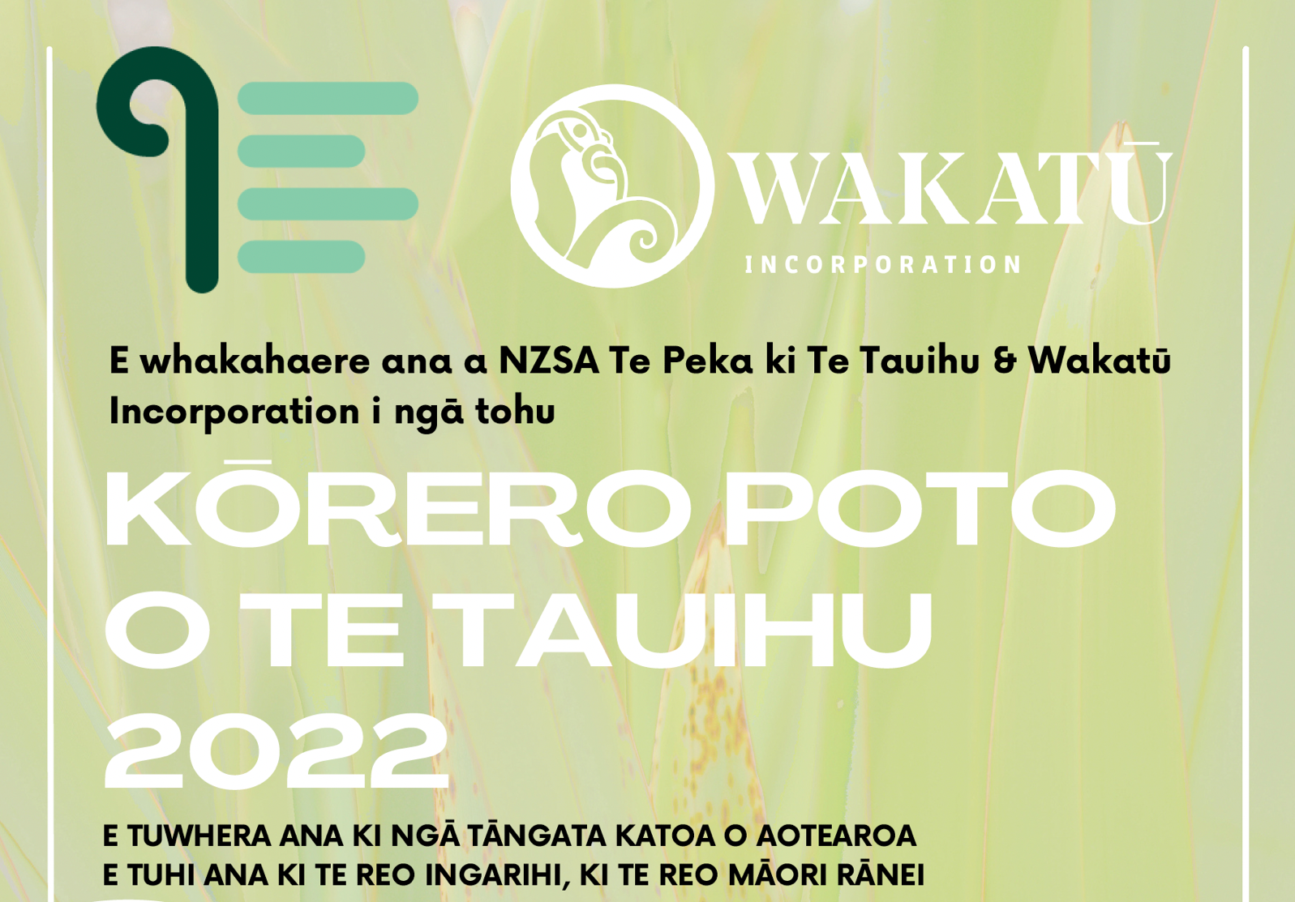
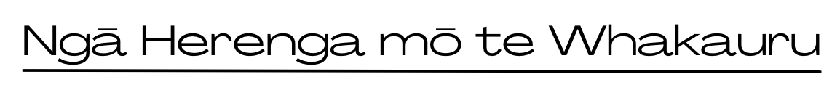
Te āheitanga
- E tuwhera ana te whakataetae nei ki ngā kaituhi e noho ana i Aotearoa tekau mā waru ngā tau, pakeke ake.
- Kaua e nui ake i te 1500 kupu. Ka whakahokia ki te kaituhi ngā whakaurunga he nui ake i tēnei ngā kupu.
- E pai ana kia tuhia ngā kōrero ki te reo Ingarihi, ki te reo Māori rānei.
- Me ū ngā tuhinga ki te āhua o te kōrero poto, ā, me uru hoki ki te wāhanga Pakeke, ki te wāhanga Rangatahi rānei.
- Kāore e whakaaetia ngā kōrero kua tāruatia, ngā tuhinga pakimaero rānei kua whakaputahia kētia, me ērā e whakaarotia ana i tēnei wā kia whakaputahia.
- Kāore e whakaaetia ngā kōrero kua whai tūranga kē, arā, kua toa, kua mihia rānei, i tētahi atu whakataetae. Kāore e whakaaetia kia whakaurua ngā kōrero ki ētahi atu whakataetae kia hipa rā anō te 30 o Hune, i te tau 2022.
- Kāore ngā tāngata o te komiti o Te Peka ki Te Tauihu o NZSA e āhei ki te uru.

Te tuku me te utu
- Me Word Document ngā whakaurunga, arā, me doc, me docx rānei.
- Ko te takoto o ngā whakaurunga, me pūrua te mokowā, me A4 te rahi, me Times New Roman te momotuhi, me te 12 te rahi o te tuhi. Kaua e nama i ngā whārangi, ā, me waiho te whārangi tuatahi mō te ingoa anahe o te kōrero. Kia kaua te ingoa o te kaituhi e kitea i te tuhinga. Me whakaingoa te kōnae ki te ingoa o te kōrero.
- Tukua mai ngā kōrero mā te īmēra anahe. Tukua ki: tetauihuawards2022@gmail.com Tāpirihia hoki te puka whakauru kei raro nei, ā, ko tō kōrero hei tāpiritanga.
- Ki te nui ake i te kotahi ō whakaurunga, me wehe ia kōrero ki tētahi īmēra motuhake.
- Kia kaua e wawe ake i te 14 o Pēpuere, i te tau 2022, tō tuku mai i ngā whakaurunga, ā, kia kaua e tōmuri atu i te weheruatanga o te 31 o Mei, i te tau 2022.
- Mā te tuku i tētahi whakaurunga e whakaae nei te kaituhi kia riro kau i Te Peka ki Te Tauihu o NZSA te mana ki te whakaputa i te tuhinga ki te pae tukutuku a te whakahaere ina kuhuna te tuhinga ki te kōwhiringa whāiti o tēnei whakataetae.
- E $20.00 tāra te utu mō ia kōrero. E $20 tāra atu anō te utu mō tētahi arotakenga ā-tuhi mō ia whakaurunga.
- Ka whiwhi ngā tuhinga katoa ka kuhuna ki te kōwhiringa whāiti i tētahi arotakenga.

Te whakawā
- Kei te kaiwhakawā te mana i runga i ngā whakataunga, ā, kāore he kōrero i tua atu i tērā.
- Ka pānuitia ngā putanga hei te 30 o Hune, i te tau 2022, ā, ka whakaputahia hoki ki www.topwriters.co.nz. Ka whakamōhiotia takitahitia ko ngā kaituhi anahe ka kuhuna ki ngā kōwhiringa whāiti.

E mihi ana ki ngā kaitautoko matua:
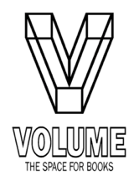
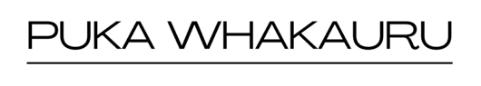
kia mārama te tuhise
Ingoa
Ingoa tuhi
(me he ingoa tuhi tōu)
Iwi
(me e hāngai ana)
He mema koe nō Te Puni Kaituhi o Aotearoa? | Āe / Kāo (Ehara i te mea me mema koe e uru ai koe)
Wāhi noho
Tau waea
Īmēra
Ingoa o te kōrero me te nui o ngā kupu

Tukuna mai tēnei puka i te taha o tō whakaurunga i mua i te weheruatanga o te 31 o Mei, i te tau 2022. Ki te nui ake i te kotahi ngā kōrero e tukuna mai ana, tēnā, whakakīia tētahi puka motuhake mō ia whakaurunga. Tēnā, tuhia te X ki te taha o ngā kōwhiringa e kōwhiri nei koe
[ ] e $20 te utu mō ia whakaurunga.
[ ] e $40 tāra te utu mō ia whakaurunga e hiahiatia ana hoki tētahi arotakenga.

[ ] ka tuku ā-hiko nei ahau i te utu ki te kaute pēke o te pēke o NBS 03-1354-0544245-00
[ ] ka tuku ā-tinana ahau i te utu ki tētahi peka o te pēke o NBS, ki te kaute pēke kei runga nei
I ēnei kōwhiringa e rua, whakamahia tō ingoa whānau me ‘SSComp’ hei tohutoro.

Tēnā, īmērahia ngā whakaurunga ki: tetauihuawards2022@gmail.com

Mō ētahi atu mōhiohio: www.topwriters.co.nz īmēra rānei ki tosnzsa15@gmail.com

