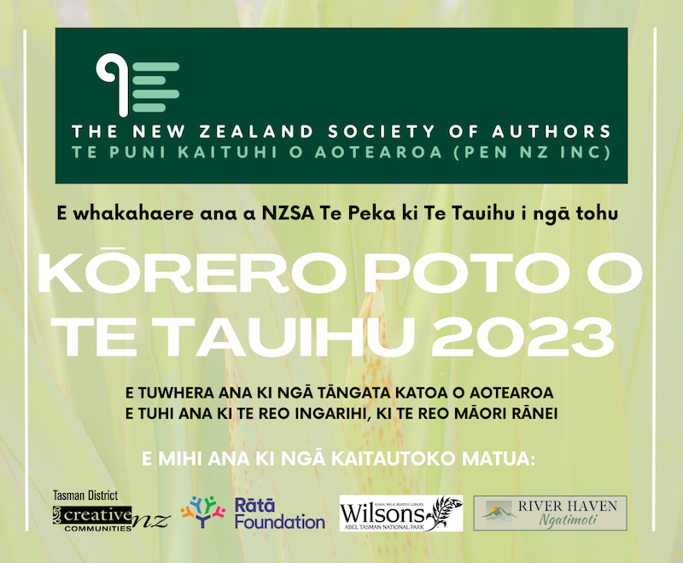
Te Āheitanga
- E tuwhera ana ki ngā kaituhi e noho ana i Aotearoa tekau mā waru ngā tau, pakeke ake.
- Kaua e nui ake i te 1500 kupu. Kāore e whakaaetia ngā whakaurunga he nui ake i tēnei ngā kupu.
- E pai ana kia tuhia ngā kōrero ki te reo Ingarihi, ki te reo Māori rānei.
- Me ū ngā tuhinga ki te āhua o te kōrero poto, ā, me uru hoki ki te wāhanga Pakeke, ki te wāhanga Rangatahi rānei.
- Kāore e whakaaetia ngā kōrero kua tāruatia, ngā tuhinga pakimaero rānei kua whakaputahia kētia, me ērā e whakaarotia ana i tēnei wā kia whakaputahia.
- Kāore e whakaaetia ngā kōrero kua whai tūranga kē (arā, kua toa, kua mihia rānei) i tētahi atu whakataetae. Kāore e whakaaetia kia whakaurua ngā kōrero ki ētahi atu whakataetae kia hipa rā anō te 30 o Hune, i te tau 2023.
- Kāore ngā mema o te komiti o Te Peka ki Te Tauihu o NZSA e āhei ki te uru.

Te Tuku me te Utu
- Me whakatutuki ngā whakaurunga i ngā paearu hōputu e whai ake nei
  - Me tuhinga A4 te rahi
  - Me pūrua te mokowā
  - Me Times New Roman te momotuhi, me te 12 te rahi o te tuhi
  - Me nama ngā whārangi
  - Ko te taitara te upoko i te whārangi tuatahi
  - Me kaua te ingoa o te kaituhi e kitea i te tuhinga
  - Me whakaingoa te kōnae ki te ingoa o te kōrero.

- Tukua mai ngā kōrero mā te īmēra anahe. Tukua ki: tetauihushortstory@gmail.com
- Tāpirihia te puka whakauru (kei raro nei) me tō kōrero hei tāpiritanga.
- Ki te nui ake i te kotahi ō kōrero hei whakaurunga, me tuku ia kōrero ki tētahi īmēra motuhake.
- Kia kaua e tōmuri ake i te 5 karaka i te ahiahi, hei te 31 o Mei i te tau 2023 te taenga mai o ngā whakaurunga
- Mā te tuku i tētahi whakaurunga, e whakaae nei te kaituhi kia riro i Te Peka ki Te Tauihu o NZSA te mana, ehara i te mana motuhake mōna ake, ki te whakaputa i te tuhinga ki te pae tukutuku a te peka ina kuhuna te tuhinga ki te kōwhiringa whāiti o tēnei whakataetae. Tae atu ki te 10 ngā whakaurunga ki ia kōwhiringa reo ka kuhu atu ki te kōwhiringa whāiti.
- E $20.00 tāra te utu mō ia whakaurunga mō te tangata e 26 ngā tau, neke atu rānei, ā, $10 mō ia whakaurunga 18-25 ngā tau . E $20 tāra atu anō te utu mō tētahi arotakenga ā-tuhi mō ia whakaurunga.

Te Whakawā
- Kei te kaiwhakawā te mana i runga i ngā whakataunga, ā, kāore he kōrero i tua atu i tērā.
- Ka pānuitia ngā whakaurunga ka kuhu ki te kōwhiringa whāiti hei te 30 o Hune, i te tau 2023, ā, ka whakaputahia hoki ki www.topwriters.co.nz.

E mihi ana ki ngā kaitautoko matua:
…

Puka Whakauru mō Ngā Tohu Kōrero Poto o Te Tauihu 2023
Kia mārama te tuhi
Ingoa Tapa
Ingoa Tuhi
(me he ingoa tuhi tōu)
Iwi
(me e hāngai ana)
Pakeke | I waenga i te 18-25 ngā tau | E 26 tau, neke atu rānei
He mema koe nō NZSA? | Āe / Kāo (Ehara i te mea me mema koe o te NZSA e uru ai koe)
Wāhi Noho
Tau Waea
Īmēra
Ingoa o te Kōrero me te Nui o ngā Kupu

Tukuna mai tēnei puka i te taha o tō whakaurunga i mua i te 5 karaka i te ahiahi, hei te 31 o Mei, i te tau 2023. Ki te nui ake i te kotahi ngā kōrero e tukuna mai ana e koe, tēnā, whakakīia tētahi puka whakauru motuhake mō ia whakaurunga.

Tēnā, tuhia te X ki te taha o ngā kōwhiringa e kōwhiri nei koe ki raro nei:

[ ] e $20 te utu mō ia whakaurunga mō te tangata e 26 ngā tau, neke atu rānei
[ ] $10 te utu mō ia whakaurunga mō te tangata 18-25 ngā tau
[ ] e $20 tāra te utu tāpiri mō ia whakaurunga e hiahiatia ana hoki tētahi arotakenga.

[ ] ka tuku ā-hiko nei ahau i te utu ki te kaute pēke o te pēke o NBS 03-1354-0544245-00
[ ] ka tuku ā-tinana ahau i te utu ki tētahi peka o te pēke o NBS, ki te kaute pēke kei runga nei
I ēnei kōwhiringa e rua, whakamahia tō ingoa whānau me ‘SSComp’ hei tohutoro.

Tēnā, īmērahia ngā whakaurunga ki: tetauihushortstory@gmail.com

Mō ētahi atu mōhiohio: www.topwriters.co.nz īmēra rānei ki tosnzsa15@gmail.com

…

